What is
Anthropology?
Anthropology is the study of humans, past and present. Anthropology builds upon knowledge from the social and biological sciences as well as the humanities and physical sciences.
Anthropologists investigate and apply knowledge to solve human problems using a four-field approach:
- Cultural
- Archaeology
- Biological
- Linguistics

Why
Anthropology?
Anthropologists want to know why. For example, we know how Zika is spreading but do we know why?

Anthropologists
are in demand
Employers of all types want the specific skills of anthropologists including health care fields, governments, non-profit, and private companies.
Anagnostis P. Agelarakis
Department Chair
agelarakis@adelphi.edu
Adelphi University
Department of Anthropology
Alumnae Hall Room 218
1 South Avenue
Garden City, New York 11530

T (516) 877-4110
F (516) 877-4717
anthropology.adelphi.edu
facebook.com/AUANTHRO
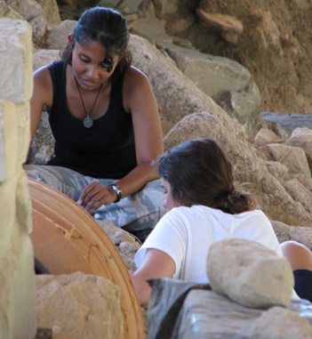
Anthropology

Benefits of
Anthropology Degree
- This is benefit one of anthropology
- This is benefit two of anthropology degree
- Having a BA in Anthropology Benefit Three
- There is this fourth benefit to having an anthropology degree.
Our Alumni
Google hired an ethnographer to ferret out the meaning of mobile. Intel has an in-house cultural anthropologist, and Microsoft is repor.tedly the second-largest employer of anthropologists in the world

Learning
Experiences
Summer Field Programs
Adelphi in Crete
Adelphi in Alaska
B.A. in Anthropology
40 Credits Required for Major
120 Credits to Graduate

Core Requirements (17 credits)
0103.111 - Cultural Anthropology
0103.112 - Physical Anthropology
0103.113 - Archaeology
0103.325 - History of Anthropological Theory
0103.360 - Fieldwork Methods

Cultural Anthropology (choose at least one)
0103.227 - Peoples of the North
0103.238 - Blood, Sex and Kinship
0103.242 - Psychological Anthropology
0103.248 - Culture And Health
0103.251 - Anthropology of Religion
0103.265 - The Developing World

Physical Anthropology (choose at least one)
0103.225 - Human Evolution
0103.253 - Scientific Illustration
0103.333 - Fieldwork & Lab Techniques
0103.362 - Jaws, Teeth and Forensic Dentistry
0103.441 - Forensic Anthropology

Archaeology (choose at least one)
0103.223 - Archaeology of New World
0103.244 - Rise and Fall of Civilization
0103.252 - Technical Drawing in Archaeology
0103.322 - Archaeology of Animals
0103.332 - Archaeological Field Methods in Alaska
0103.333 - Summer Field School in Crete
0103.369 - Ancient Warfare: The Classical Era

Degrees
Offered
BA Anthropology
Minor Anthropology
The B.A. in Anthropology with an Environmental Anthropology Concentration provides an opportunity for students to complete the degree requirements through courses focused primarily on the interaction of humans with their environment.
Faculty
Anagnostis P. Agelarakis
Department Chair
agelarakis@adelphi.edu
Anagnostis P. Agelarakis
Department Chair
agelarakis@adelphi.edu
Anagnostis P. Agelarakis
Department Chair
agelarakis@adelphi.edu
agelarakis@adelphi.edu
Anagnostis P. Agelarakis
Department Chair
agelarakis@adelphi.edu
agelarakis@adelphi.edu

